Volumetric Calculations

1. 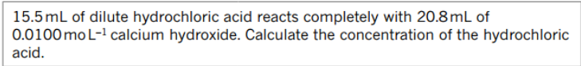
2. 

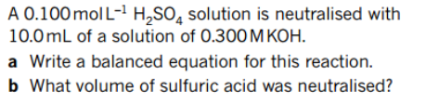3.

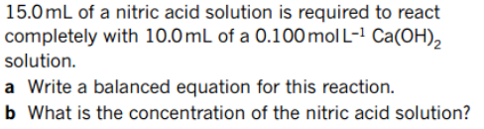4.

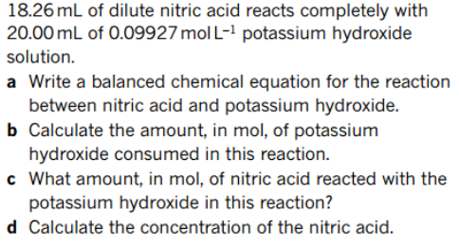5.

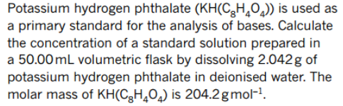6.

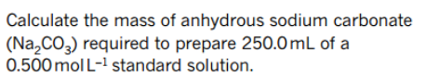7.

8. 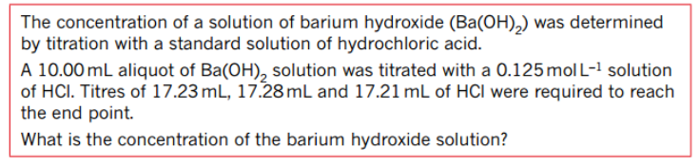

**9.**

**10.**

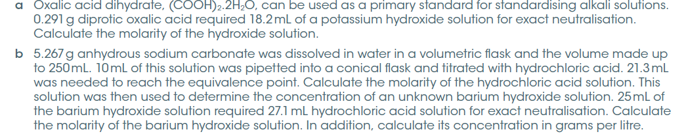

**Titration Involving Dilution**

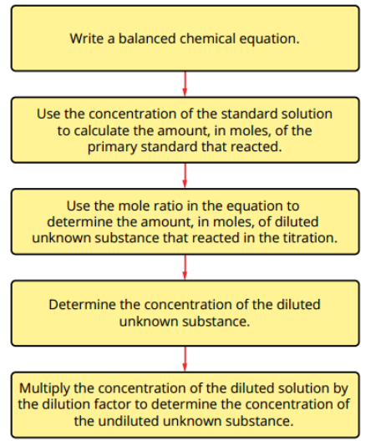

1. 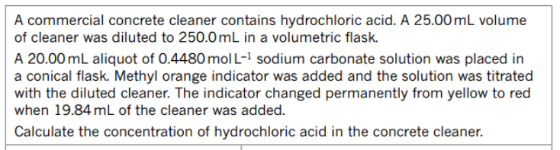
2. 